CURRICULUM VITAE

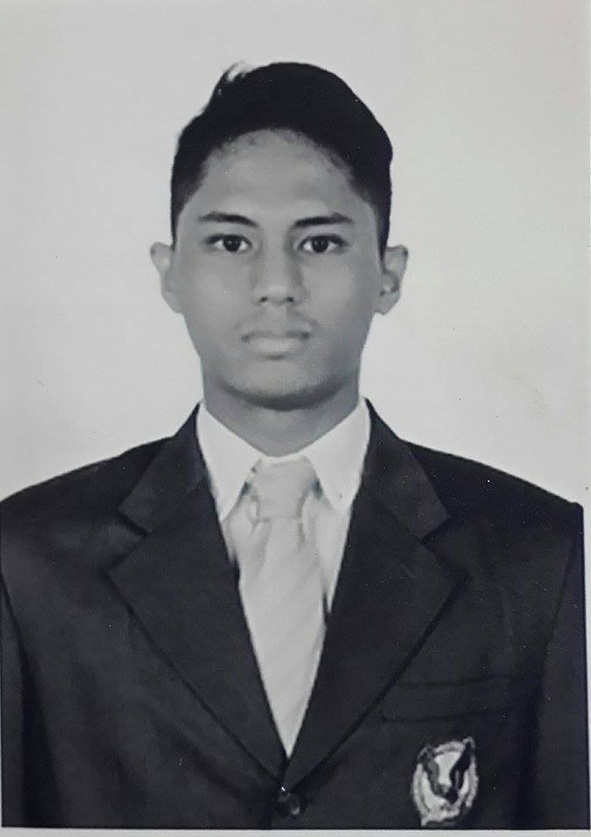

PERSONAL DATA

Name : | Adhitya Poernama
Place/Date of Birth : | Pekanbaru, August 26th 1989
Religion : | Moslem
Sex : | Male
Address : | Jl. Banjar Kav 648 Blok M, Cinere, Depok, 16514
Mobile Phone : | 0813-1597-8474
Email : | Apoerna26@gmail.com
GPA : | 2.96
SKILLS
Personal Skill |  | : Great analytical skills, independent and self motivated, High spirited and enthusiastic , able to work as a team, sensitive and able to observe in a fine detail, willing to serve others, and sensitive to new information.
Computer Skill |  | : Mastering in Microsoft Word, PowerPoint, Excel and proficient at 3D & visual design programs such as 3DS Max, Google Sketchup, Vray, Maya, Photoshop, InDesign, After Effect, Premiere and Illustrator.
Language |  | : English (TOEFL score: 537)  Bahasa Indonesia

EDUCATION
2014  2013  2012 – 2013  2007 – 2012  2004 – 2007  2003 – 2004 | Animation & Story Masterclass by PIXAR  "French Animation School" Masterclass  Graphic Connection  Basic Graphic Design Program  Intermediate Graphic Design Program  Basic Motion Graphic Program  Ultimate Motion Graphic Program  3DS Max Program  Universitas Pelita Harapan Karawaci  Informatics Engineering  SMA Labschool Cinere  MG Yamaha PMC Classic Guitar Course | Jakarta  Jakarta  Tangerang  Tangerang  Jakarta  Pekanbaru

ACTIVITY

2013 - 2014  2012 - 2013  2013  2013  2012  2008 - 2009  2008  2007 | Joined Michael Brohet Architects. Filled the position for Graphic Designer, 3D Designer and Render Artist. I experienced the process of brainstorming, concepting, and visualizing in architecture, understanding the differences of building materials.  Social Media Strategist at DM-RCubed (now RedSpace) of WIR Group. Assigned as an administrator and responsible in analysing, managing and evolving brands with engaging methodologies to bridge the connection between end users and associated brands. I administered Pacific Royale Airways (May 2012 – December 2012), The Duck King (May 2012 – June 2014), Pigeon Teens (August 2012 – December 2012), Pigeon Baby (August 2012 – December 2012), CIMB Niaga (January 2013 – February 2013), The Foodhall (January 2013 – March 2013).  Appeared as Guest in Reality Show "Dating Ala Chef" with Indonesian Chef Ari Galih Gumilang for Channel Hi!-TV at First Media.  Participated in the Gerakan Indonesia Mengajar Festival. As a volunteer, assisted in various projects to aid children's education, which later to be sent to Elementary Schools in Indonesia.  Finished my final thesis, “Minimax Algorithm Implementation on the Connect Four Game”  The Minimax Algorithm is a method of evaluating every legal move from both players of views. The implementation consists of game type and artificial inteligence. By applying the Minimax Algorithm onto the game Connect Four was to  determine the extent of the successful rate of the Minimax Algorithm on the game Connect Four by choosing the best positions on computer's each executed step.  Joined Intra-School Student Organization (OSIS). As the Head of Bela Negara Division, in charge of sustaining leadership within the Student Organization.  Fund raising and sponsorship coordinator at SMA Labschool Cinere performing arts Elysium.  Proposed to various significant companies to sponsored and assisted the program.  Joined the "Trip Observasi" School Program at Sukabumi, with Labschool Cinere's sophomore students. We were assigned in groups and placed in local homes at Sukabumi.  Assigned as the group leader, received various tasks to increase leadership skill, teamwork skill and independence. | Jakarta  Jakarta  Jakarta  Tangerang  Tangerang  Jakarta  Jakarta  Sukabumi

ORGANIZATION EXPERIENCES

2008  2008 | Fund raising and sponsorship coordinator at SMA Labschool Cinere yearly performing arts Elysium.  Proposed to various significant companies to sponsored and assisted the program.  Head of Bela Negara Division Intra-School Student Organization (OSIS)  description already stated in the activity section | Jakarta  Jakarta

HOBBIES AND INTERESTS

I enjoy watching TV Series and Movies in my spare time. Always exploring new stuff and practicing my skill as a CG Artist. A fan of literatures. A sports fan as well, I play Basketball and Football.

Jakarta, March 2015


Adhitya Poernama.

